8. Change the location name of “Door” to “Gate” for the row inserted in modification problem 2.

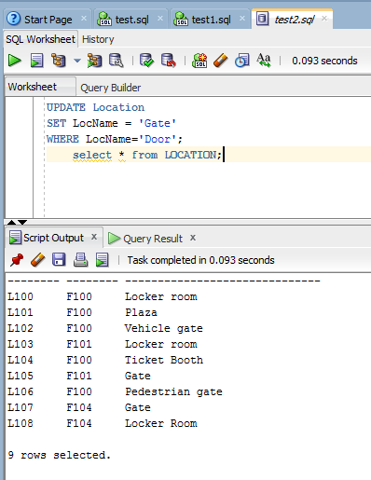

UPDATE Location

SET LocName = 'Gate'

WHERE LocName='Door';